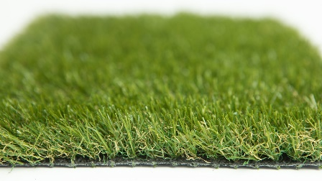

Specification Sheet: Setaria
An ultra-thick mid-ranged artificial grass. Setaria has a super thick light brown thatch that helps to support the 30mm yarn. This results in a beautifully soft product the kids will love to run around on. The brilliant texture of Setaria coupled with a realistic look, creates the perfect all round grass.
Setaria – 30mm Pile Height
- Manufacturer – Nomow Ltd
  - Web: www.nomow.co.uk
  - Tel: 0800 587 0380
  - Product reference: Setaria

Fibre: 65% PE /35% PP straight / curled
Fibre Shape: Xtra Spine Technology
Pile height: ca. 30mm
# Stitches: ca. 21/ 10 cm
Production: Tufting
Gauge: 3/8”
# Tufts: ca. 22,050 / m²
Pile weight: ca. 1,022 gr / m²
Total weight: ca. 1,992 gr / m²
Tuft cloth: Polypropylene woven, ca. 170 gr / m²
Backing: Pre coat, ca. 800 gr / m²
Roll width: 400 cm
Roll length: ±25 m
UV Stability: > 3,000 hours UV-A │6,000 hours XENON
Light fastness: Scale 7 (DIN 54004)
Chlorine resistance: 4 –5 (DIN 54019)
Resistance to sea water: 4 –5 (DIN 54007)

“Nomow has the right to alter each product specification in order to improve the artificial grass according to the newest technological applications. Nomow is not legally liable in case of non-compliance with these mentioned specifications.”

