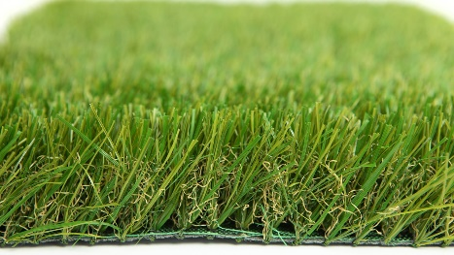

Specification Sheet: Luxury Plus 2020
A silky-smooth grass combined with density and softness. The four colours gives a truly natural appearance and is highly recommended for both gardens and landscaping.
Luxury Plus 2020 – 40mm Pile Height
- Manufacturer – Nomow Ltd
  - Web: www.nomow.co.uk
  - Tel: 0800 587 0380
  - Product reference: Luxury Plus 2020

Fibre: 75% PE /25% PE straight / curled
Fibre Shape: W-shape + C Rib + Xtra Spine Technology
Pile height: ca. 40mm
# Stitches: ca. 23/ 10 cm
Production: Tufting
Gauge: 3/8”
# Tufts: ca. 24,150 / m²
Pile weight: ca. 1,868 gr / m²
Total weight: ca. 2,838 gr / m²
Tuft cloth: Polypropylene woven, ca. 170 gr / m²
Backing: Pre coat, ca. 800 gr / m²
Roll width: 400 cm
Roll length: ±25 m
UV Stability: > 3,000 hours UV-A │6,000 hours XENON
Light fastness: Scale 7 (DIN 54004)
Chlorine resistance: 4 –5 (DIN 54019)
Resistance to sea water: 4 –5 (DIN 54007)

“Nomow has the right to alter each product specification in order to improve the artificial grass according to the newest technological applications. Nomow is not legally liable in case of non-compliance with these mentioned specifications.”

