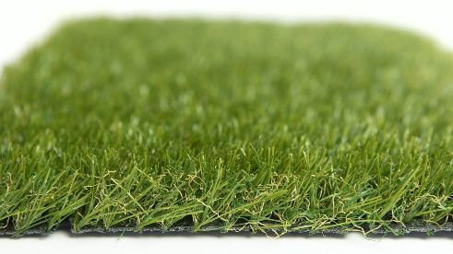

Specification Sheet: Vitality
A lovely artificial grass that provides fantastic value for money. Vitality is a superb looking artificial grass with a neat short pile height and a nice feel. Perfect for small gardens and amazing at transforming grey, concrete spaces.
Vitality – 23mm Pile Height
- Manufacturer – Nomow Ltd
  - Web: www.nomow.co.uk
  - Tel: 0800 587 0380
  - Product reference: Vitality

Fibre | 65% PE /35% PP straight / curled
Fibre Shape | Xtra Spine Technology (XST)
Pile height | ca. 23mm
# Stitches | ca. 21 / 10 cm
Production | Tufting
Gauge | 3/8”
# Tufts | ca. 22,050 / m²
Pile weight | ca. 808 gr / m²
Total weight | ca. 1778 gr / m²
Tuft cloth | Polypropylene woven, ca. 170 gr / m²
Backing | Pre coat, ca. 800 gr / m²
Roll width | 400 cm
Roll length | ±25 m
UV Stability | > 3,000 hours UV-A │6,000 hours XENON
Light fastness | Scale 7 (DIN 54004)
Chlorine resistance | 4 –5 (DIN 54019)
Resistance to sea water | 4 –5 (DIN 54007)

“Nomow has the right to alter each product specification in order to improve the artificial grass according to the newest technological applications. Nomow is not legally liable in case of non-compliance with these mentioned specifications.”

