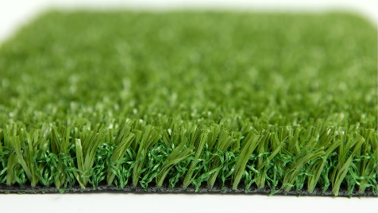

Specification Sheet: Stadia 24
Stadia 24 is an innovation for Artificial Grass Sports Surfaces. The unique combination of a tough fibrillated Artificial Grass supported by a curled Monofilament layer means, that Stadia 24 is a quality Synthetic Sports Surface that doesn’t require a sand or rubber crumb in-fill.
Stadia 24 – 24mm Pile Height
- Manufacturer – Nomow Ltd
  - Web: www.nomow.co.uk
  - Tel: 0800 587 0380
  - Product reference: Stadia 24

Fibre | 100% PE straight / curled
Pile height | ca. 22mm
# Stitches | ca. 21 / 10 cm
Production | Tufting
Gauge | 3/16”
# Tufts | ca. 44,100 / m²
Pile weight | ca. 2018 gr / m²
Total weight | ca. 3270 gr / m²
Tuft cloth | Polypropylene woven, ca. 252 gr / m²
Backing | Pre coat ca. 1000 gr / m²
Roll width | 400 cm
Roll length | ±25 m
UV Stability | > 3,000 hours UV-A │6,000 hours XENON
Light fastness | Scale 7 (DIN 54004)
Chlorine resistance | 4 –5 (DIN 54019)
Resistance to seawater | 4 –5 (DIN 54007)

“Nomow has the right to alter each product specification in order to improve the artificial grass according to the newest technological applications. Nomow is not legally liable in case of non-compliance with these mentioned specifications.”

