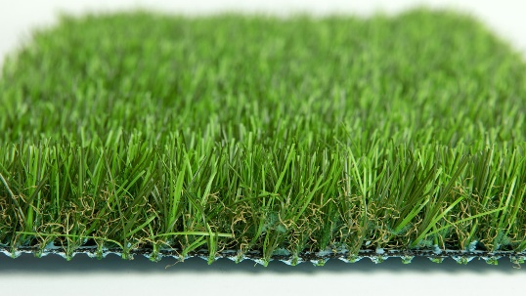

Specification Sheet: Pure Play
Pure Play is a revolutionary artificial grass which is made using the breakthrough material, PURETi. The grass has a number of unique characteristics and exceptional qualities. One of the primary abilities of Pure Play is its disinfectant properties and ability to act as a catalyst in destroying bacteria, fungi and viruses. In addition, Pure Play is also able to break down air pollutants such as Volatile Organic Compounds (VOCs) and Nitrogen Dioxide (NOx). 1m2 of Pure Play is able to clean the same volume of air as a full tree.
Due to its exceptional abilities Pureti has received support and recognition for sustainability and innovation from a number of high profile organisation such as; NASA Dual Use Technology Partner, the European iSCAPE Project, Architectural Products Innovation Award, Edison Award in Materials Technology - Safety & Sustainability Category and Katerva Award for Sustainability.
The actual artificial grass is based on our Pro Play product. It is just as durable, with a multi-toned pile and a light brown thatch. It has a fantastic feel and is a fun and vibrant surface for kids to play on. Pure Play has a special blue backing on the underside which distinguishes it as containing PURETi.
Pure Play – 32mm Pile Height
- Manufacturer – Nomow Ltd
  - Web: www.nomow.co.uk
  - Tel: 0800 587 0380
  - Product reference: Pure Play
Fibre | 75% PE / 25% PP
Production Method | Tufting
Gauge | 3/8”
# stitches / lm | ca. 190 / lm
# tufts / m² | ca. 19,950 / m²
Pile Height | ca. 31 mm
Pile Weight | ca. 1,393 g / m²
Total Weight | ca. 2,363 g / m²
Tuft Cloth | Polypropylene woven, ca. 170 g / m²
Backing | Latex, ca. 800 g / m²
Roll width | 400 cm
Colour Fastness | Scale 7 (DIN 54004)
UV-Stability | > 3,000 hours UV-A
Chlorine Resistance | 4 – 5 (DIN 54019)
Resistance to sea water | 4 – 5 (DIN 54007)
Pureti | 0.02 g / m²

“Nomow has the right to alter each product specification in order to improve the artificial grass according to the newest technological applications. Nomow is not legally liable in case of non-compliance with these mentioned specifications.”

