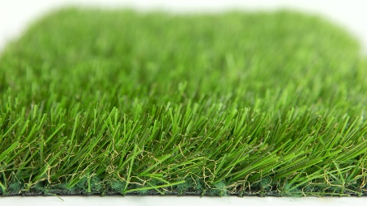

Specification Sheet: Pro Play
Pro Play is used in schools and public playgrounds up and down the country. It has been specifically designed with playgrounds in mind. It has a bright, 32mm multi-coloured pile and is extremely robust making it the perfect choice for schools and nurseries.
Pro Play – 32mm Pile Height
- Manufacturer – Nomow Ltd
  - Web: www.nomow.co.uk
  - Tel: 0800 587 0380
  - Product reference: Pro Play

Fibre | 75 % PE / 25 % PP straight / curled
Fibre Shape | Airblade Max Diamond
Production Method | Tufting
Gauge | 5/16”
#stitches / lm | ca. 155/ lm
#tufts / m² | ca. 19,530 / m²
Pile Height | ca. 30 mm
Pile Weight | ca. 1387 g / m²
Total Weight | ca. 2352 g / m²
Tuft Cloth | Polypropylenewoven, ca. 170 g / m²
Backing | Latex, ca. 800 g / m²
Roll width | 400 cm
Roll length | 25 m
Colour Fastness | Scale 7 (DIN 54004)
UV-Stability | > 3,000 hours UV-A
Chlorine Resistance | 4 –5 (DIN 54019)
Resistance to sea water | 4 –5 (DIN 54007)

“Nomow has the right to alter each product specification in order to improve the artificial grass according to the newest technological applications. Nomow is not legally liable in case of non-compliance with these mentioned specifications.”

