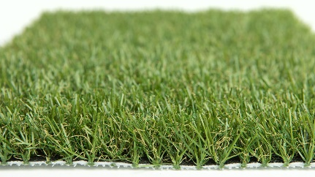

Specification Sheet: Pet 28
Pet 28 is a luxurious Artificial Grass that has been specifically designed to be suitable for dogs and pets. It has been designed to work in conjunction with our ZeoZorb product. The grass has an impressive 28mm Pile Height which allows a layer of the ZeoZorb to sit within the grass, whilst not being visible. ZeoZorb is a special substance that is used alongside artificial grass to help eliminate odours. It has the remarkable ability of being able to absorb ammonia particles in dog urine and then, after some rainfall, it is able to reset and re-absorb even more ammonia.
Pet 28 – 28mm Pile Height
- Manufacturer – Nomow Ltd
  - Web: www.nomow.co.uk
  - Tel: 0800 587 0380
  - Product reference: Pet 28

Fibre | 75% PE /25% PP straight / curled
Fibre Shape | MicroNerve Technology (Mint)
Pile height | ca. 28mm
# Stitches | ca. 18 / 10 cm
Production | Tufting
Gauge | 3/8”
# Tufts | ca. 18,900 / m²
Pile weight | ca. 1211 gr / m²
Total weight | ca. 2131 gr / m²
Tuft cloth | Polypropylene woven, ca. 170 gr / m²
Backing | Polyurethane ca . 750 gr / m²
Roll width | 400 cm
Roll length | ±25 m
UV Stability | > 3,000 hours UV-A │6,000 hours XENON
Light fastness | Scale 7 (DIN 54004)
Chlorine resistance | 4 –5 (DIN 54019)
Resistance to sea water | 4 –5 (DIN 54007)

“Nomow has the right to alter each product specification in order to improve the artificial grass according to the newest technological applications. Nomow is not legally liable in case of non-compliance with these mentioned specifications.”

