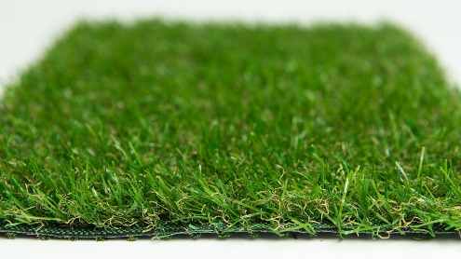

Specification Sheet: New Meadow 21
One of the best looking artificial grasses for its price range, ever. At only 20mm, New Meadow incorporates multiple shades of darker green in the yarn with two types of thatch. New Meadow has been built with attention to detail yet is affordable for customers on a tight budget.
New Meadow 21 – 20mm Pile Height
- Manufacturer – Nomow Ltd
  - Web: www.nomow.co.uk
  - Tel: 0800 587 0380
  - Product reference: New Meadow 21

Fibre | 65% PE/35%PP
Production Method | Tufting
Gauge | 3/8”
#stitches / lm | ca. 170/ lm
#tufts / m² | ca. 17.850 / m²
Pile Height | ca. 20 mm
Pile Weight | ca. 594 g / m²
Total Weight | ca. 1,564 g / m²
Tuft Cloth | Polypropylenewoven, ca. 170 g / m²
Backing | Latex, ca. 800 g / m²
Roll width | 400 cm
Colour Fastness | Scale 7 (DIN 54004)
UV-Stability | > 3,000 hours UV-A
Chlorine Resistance | 4 –5 (DIN 54019)
Resistance to sea water | 4 –5 (DIN 54007)

“Nomow has the right to alter each product specification in order to improve the artificial grass according to the newest technological applications. Nomow is not legally liable in case of non-compliance with these mentioned specifications.”

