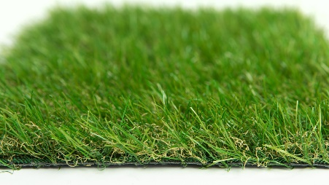

Specification Sheet: Moorland
Moorland is a 30mm artificial grass with a multitoned pile and light brown thatch. This grass is perfect for family gardens where real turf isn’t suitable. A great value, realistic artificial grass.
Moorland – 30mm Pile Height
- Manufacturer – Nomow Ltd
  - Web: www.nomow.co.uk
  - Tel: 0800 587 0380
  - Product reference: Moorland

Fibre | 65% PE/35% PP
Production Method | Tufting
Gauge | 3/8”
#stitches / lm | ca. 125/ lm
#tufts / m² | ca. 13,125 / m²
Pile Height | ca. 29 mm
Pile Weight | ca. 620 g / m²
Total Weight | ca. 1,590 g / m²
Tuft Cloth | Polypropylenewoven, ca. 170 g / m²
Backing | Latex, ca. 800 g / m²
Roll Width | 400 cm
Colour Fastness | Scale 7 (DIN 54004)
UV-Stability | > 3,000 hours UV-A
Chlorine Resistance | 4 –5 (DIN 54019)
Resistance to sea water | 4 –5 (DIN 54007)

“Nomow has the right to alter each product specification in order to improve the artificial grass according to the newest technological applications. Nomow is not legally liable in case of non-compliance with these mentioned specifications.”

