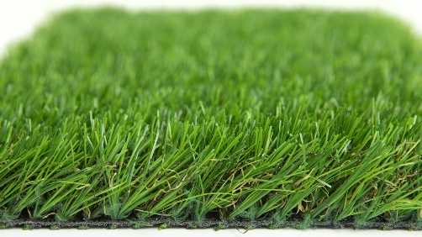

Specification Sheet: Manor
Manor is an excellent 35mm premium grass. A top of the range Artificial Grass that is designed to withstand high levels of activity and is therefore perfect for family gardens. The grass also features a dense realistic mid-brown thatch which adds a darker tone to the grass.
Manor – 35mm Pile Height
- Manufacturer – Nomow Ltd
  - Web: www.nomow.co.uk
  - Tel: 0800 587 0380
  - Product reference: Manor

Fibre | 70 % PE / 30 % PP straight / curled
Fibre Shape | Diamand
Production Method | Tufting
Gauge | 3/8”
#stitches / lm | ca. 140/ lm
#tufts / m² | ca. 14,700 / m²
Pile Height | ca. 36 mm
Pile Weight | ca. 1924 g / m²
Total Weight | ca. 2894 g / m²
Tuft Cloth | Polypropylenewoven, ca. 170 g / m²
Backing | Latex, ca. 800 g / m²
Roll Width | 400 cm
Roll Length | 25 m
Colour Fastness | Scale 7 (DIN 54004)
UV-Stability | > 3,000 hours UV-A
Chlorine Resistance | 4 –5 (DIN 54019)
Resistance to sea water | 4 –5 (DIN 54007)

“Nomow has the right to alter each product specification in order to improve the artificial grass according to the newest technological applications. Nomow is not legally liable in case of non-compliance with these mentioned specifications.”

