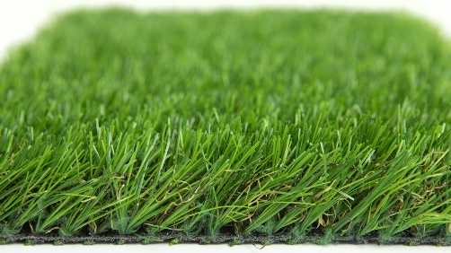

Specification Sheet: Kingdom
Each individual blade of Kingdom is reinforced with an extra strong spine. This allows the yarn in Kingdom to spring back to its original position whenever compressed. In addition, a thick multi-toned thatch provides extra support and a realistic look.
Kingdom – 38mm Pile Height
- Manufacturer – Nomow Ltd
  - Web: www.nomow.co.uk
  - Tel: 0800 587 0380
  - Product reference: Kingdom
Fibre | 65 % PE / 35 % PP straight / curled
Fibre Shape | Xtra Spine Technology (XST)
Pile height | ca. 38 mm
# Stitches | ca. 260 st/ m
Production | Tufting
Gauge | 3/8”
# Tufts | ca. 27,300 / m²
Pile weight | ca. 1555 gr / m²
Total weight | ca. 2555 gr / m²
Tuft cloth | Polypropylene woven, ca. 170 gr / m²
Backing | Pre coat ca. 800 gr / m²
Roll width | 400 cm
Roll length | ± 25 m
UV Stability | > 3,000 hours UV-A │ 6,000 hours XENON
Light fastness | Scale 7 (DIN 54004)
Chlorine resistance | 4 – 5 (DIN 54019)
Resistance to seawater | 4 – 5 (DIN 54007)

“Nomow has the right to alter each product specification in order to improve the artificial grass according to the newest technological applications. Nomow is not legally liable in case of non-compliance with these mentioned specifications.”

