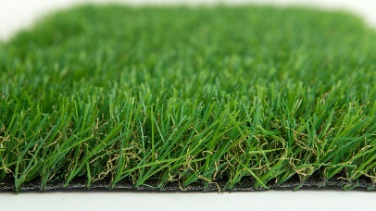

Specification Sheet: Imperial 19
Imperial is a stunning grass which is soft and springy to touch. It has a superb multitone 35mm pile with a dense brown thatch. Imperial has a memory pile to give you a lush lawn throughout the year.
Imperial 19 – 35mm Pile Height
- Manufacturer – Nomow Ltd
  - Web: www.nomow.co.uk
  - Tel: 0800 587 0380
  - Product reference: Imperial 19

Fibre | 65 % PE / 35 % PP straight / curled
Fibre Shape
Production Method | Tufting
Gauge | 3/8”
#stitches / lm | ca. 175st/lm
#tufts / m² | ca. 18375 / m²
Pile Height | ca. 35 mm
Pile Weight | ca. 1407 g / m²
Total Weight | ca. 2377 g / m²
Tuft Cloth | Polypropylenewoven, ca. 170 g / m²
Backing | Latex, ca. 800 g / m²
Roll width | 400 cm
Roll length | 25 m
Colour Fastness | Scale 7 (DIN 54004)
UV-Stability | > 3,000 hours UV-A
Chlorine Resistance | 4 –5 (DIN 54019)
Resistance to sea water | 4 –5 (DIN 54007)
“Nomow has the right to alter each product specification in order to improve the artificial grass according to the newest technological applications. Nomow is not legally liable in case of non-compliance with these mentioned specifications.”

