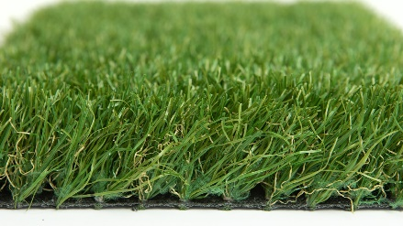

Specification Sheet: Garden Scape 21
Variable Pile Heights with the Top Pile height being 44mm. Garden Scape 21 is a new type of artificial grass. It is manufactured to have variable pile heights for the ultimate realistic effect. This effect coupled with the exceptional 44mm pile height gives Garden Scape 21 the immediate appearance of a beautiful and blissful garden area.
Garden Scape 21 – 44mm Pile Height (Variable)
- Manufacturer – Nomow Ltd
  - Web: www.nomow.co.uk
  - Tel: 0800 587 0380
  - Product reference: Garden Scape 21

Fibre: 60% PE/40% PP straight / curled
Production Method: Tufting
Gauge: 5/8”
# stitches / lm: ca. 180 / lm
# tufts / m²: ca. 11,340 / m²
Pile Height: ca. 44 mm
Pile Weight: ca. 2148 g / m²
Total Weight: ca. 3118 g / m²
Tuft Cloth: Polypropylene woven, ca. 170 g / m²
Backing: Latex, ca. 800 g / m²
Roll width: 400 cm
Colour Fastness: Scale 7 (DIN 54004)
UV-Stability: > 3000 hours UV-A
Chlorine Resistance: 4 – 5 (DIN 54019)
Resistance to sea water: 4 – 5 (DIN 54007)

“Nomow has the right to alter each product specification in order to improve the artificial grass according to the newest technological applications. Nomow is not legally liable in case of non-compliance with these mentioned specifications.”

