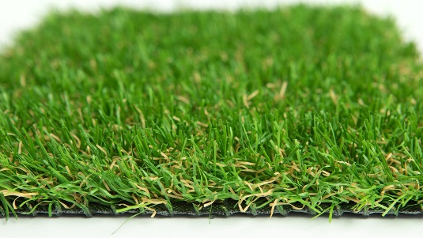

Specification Sheet: Fire Retardant Artificial Grass
The yarn in the grass has multiple shades of green at a 30mm pile height. This is complemented by a thick, sandy-brown thatch that adds to the realistic look and the overall density. An exceptional choice for indoor installations and anyone looking for a Fire Retardant material that looks and feels amazing.
Fire Retardant Artificial Grass – 30mm Pile Height
- Manufacturer – Nomow Ltd
  - Web: www.nomow.co.uk
  - Tel: 0800 587 0380
  - Product reference: Fire Retardant Artificial Grass

Fibre | 55% PE straight /45% PP curled – fire retardant – UV stabilized
Fibre Shape | Micro Nerve Technology
Pile height | ca. 30 mm
# Stitches | ca. 130 st/m
Production | Tufting
Gauge | 3/8”
# Tufts | ca. 13,650 / m²
Pile weight | ca. 1353 gr / m²
Total weight | ca. 2523 gr / m²
Tuft cloth | Polypropylene woven, ca. 170 gr / m²
Backing | Pre coat ca. 1000 gr / m² Flame Retardant
Roll width | 400 cm
Roll length | ± 30 m
UV Stability | > 3,000 hours UV-A │ 6,000 hours XENON
Light fastness | Scale 7 (DIN 54004)
Chlorine resistance | 4 – 5 (DIN 54019)
Resistance to seawater | 4 – 5 (DIN 54007)

“Nomow has the right to alter each product specification in order to improve the artificial grass according to the newest technological applications. Nomow is not legally liable in case of non-compliance with these mentioned specifications.”

