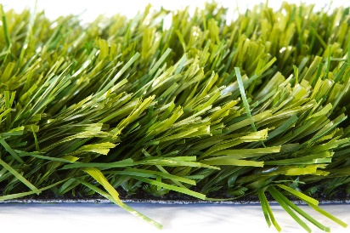

Specification Sheet: Extreme
Extreme is one of our most enduring products. It is a duo-coloured fibrillated monotype yarn designed to be filled 50% with a rubber crumb. It has technology which produces an extremely durable, safe, vandal resistant surface. It is ideal for high wear and regular sports use.
Extreme – 12mm Pile Height
- Manufacturer – Nomow Ltd
  - Web: www.nomow.co.uk
  - Tel: 0800 587 0380
  - Product reference: Extreme
Fibre | 45% PE / 55% PP
Production Method | Tufting
Gauge | 3/8”
# stitches / lm | ca. 116 / lm
# tufts / m² | ca. 12,180 / m²
Pile Height | ca. 50 mm
Pile Weight | ca. 1,513 g / m²
Total Weight | ca. 2,758 g / m²
Tuft Cloth | Polypropylene woven, ca. 295 g / m²
Backing | Latex, ca. 950 g / m²
Roll width | 400 cm
Colour Fastness | Scale 7 (DIN 54004)
UV-Stability | > 3,000 hours UV-A
Chlorine Resistance | 4 – 5 (DIN 54019)
Resistance to sea water | 4 – 5 (DIN 54007)

“Nomow has the right to alter each product specification in order to improve the artificial grass according to the newest technological applications. Nomow is not legally liable in case of non-compliance with these mentioned specifications.”

