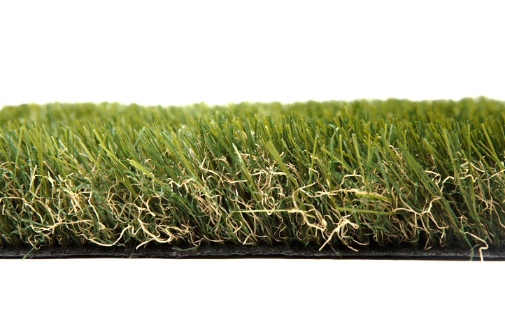

Specification Sheet: Empire
Standing at 45mm tall, Empire is an outstanding Artificial Grass that is able to replicate many of the qualities of real turf without any of the maintenance. A memory yarn produces a spongy quality that allows the Artificial Grass to spring back to its original position and imitate how grass moves. This is our most realistic grass with darker undertones and a non-shine finish.
Empire – 45mm Pile Height
- Manufacturer – Nomow Ltd
  - Web: www.nomow.co.uk
  - Tel: 0800 587 0380
  - Product reference: Empire

Fibre | 60 % PE / 40 % PP straight / curled
Fibre Shape
Production Method | Tufting
Gauge | 3/8”
# stitches / lm | ca. 175 / lm
# tufts / m² | ca. 18,375 / m²
Pile Height | ca. 48 mm
Pile Weight | ca. 1,839 g / m²
Total Weight | ca. 2,809 g / m²
Tuft Cloth | Polypropylene woven, ca. 170 g / m²
Backing | Latex, ca. 800 g / m²
Roll width | 400 cm
Roll length | 25 m
Colour Fastness | Scale 7 (DIN 54004)
UV-Stability | > 3,000 hours UV-A
Chlorine Resistance | 4 – 5 (DIN 54019)
Resistance to sea water | 4 – 5 (DIN 54007)

