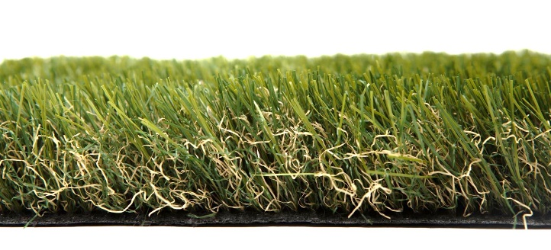

Specification Sheet: Empire
Standing at 45mm tall, Empire is an outstanding Artificial Grass that is able to replicate many of the qualities of real turf without any of the maintenance. A memory yarn produces a spongy quality that allows the Artificial Grass to spring back to its original position and imitate how grass moves. This is our most realistic grass with darker undertones and a non-shine finish.
Empire – 45mm Pile Height
- Manufacturer – Nomow Ltd
  - Web: www.nomow.co.uk
  - Tel: 0800 587 0380
  - Product reference: Empire

Fibre | 60 % PE / 40 % PP straight / curled
Fibre Shape
Production Method | Tufting
Gauge | 3/8”
# stitches / lm | ca. 175 / lm
# tufts / m² | ca. 18,375 / m²
Pile Height | ca. 48 mm
Pile Weight | ca. 1,839 g / m²
Total Weight | ca. 2,809 g / m²
Tuft Cloth | Polypropylene woven, ca. 170 g / m²
Backing | Latex, ca. 800 g / m²
Roll width | 400 cm
Roll length | 25 m
Colour Fastness | Scale 7 (DIN 54004)
UV-Stability | > 3,000 hours UV-A
Chlorine Resistance | 4 – 5 (DIN 54019)
Resistance to sea water | 4 – 5 (DIN 54007)
“Nomow has the right to alter each product specification in order to improve the artificial grass according to the newest technological applications. Nomow is not legally liable in case of non-compliance with these mentioned specifications.”

