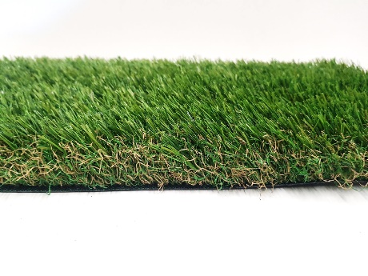

Specification Sheet: Bliss 50
Bliss 50 is a lovely, premium artificial grass that can really make an impact in your garden. Say goodbye to mud or fortnightly mowing, Bliss 50 takes away any stress and leaves a beautiful garden 365 days a year. A multi-toned thatch, and a multi-toned yarn combine to deliver an extremely realistic effect.
Bliss 50 – 50mm Pile Height
- Manufacturer – Nomow Ltd
  - Web: www.nomow.co.uk
  - Tel: 0800 587 0380
  - Product reference: Bliss 50

Fibre | 50% PE/50% PP
Production Method | Tufting
Gauge | 5/8”
#stitches / lm | ca. 220/ lm
#tufts / m² | ca. 13,860 / m²
Pile Height | ca. 50 mm
Pile Weight | ca. 2167 g / m²
Total Weight | ca. 3137 g / m²
Tuft Cloth | Polypropylenewoven, ca. 170 g / m²
Backing | Latex, ca. 800 g / m²
Roll width | 400 cm
Colour Fastness | Scale 7 (DIN 54004)
UV-Stability | > 3,000 hours UV-A
Chlorine Resistance | 4 –5 (DIN 54019)
Resistance to sea water | 4 –5 (DIN 54007)

“Nomow has the right to alter each product specification in order to improve the artificial grass according to the newest technological applications. Nomow is not legally liable in case of non-compliance with these mentioned specifications.”

