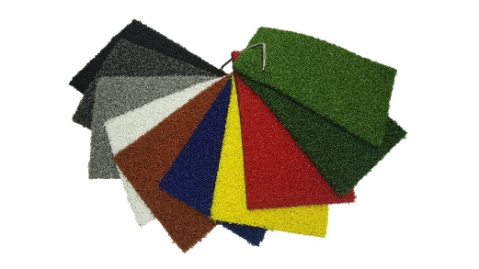

Specification Sheet: Active Play
Nomow Active Play is an innovation for Artificial Grass Sports Surfaces. The unique 100% polyethylene tufted & texturised cut pile which requires no sand infill, provides a tough, low abrasion, high quality playing surface ideal for general play and Multi Use Games Areas requiring very low maintenance.
Active Play – 12mm Pile Height
- Manufacturer – Nomow Ltd
  - Web: www.nomow.co.uk
  - Tel: 0800 587 0380
  - Product reference: Active Play

Fibre | 100% PE curled
Fibre Shape | Curled - Diamond
Pile height | ca. 11.5 mm
# Stitches | ca. 22.5/ 10 cm
Production | Tufting
Gauge | 3/16”
# Tufts | ca. 47, 250 / m²
Pile weight | ca. 1, 047 gr / m²
Total weight | ca. 2, 017 gr / m²
Tuft cloth | Polypropylene woven, ca. 170 gr / m²
Backing | Pre coat, ca. 800 gr / m²
Roll width | 200 cm / 400 cm
Roll length | ± 30.5 m
UV Stability | > 3,000 hours UV-A │ 6,000 hours XENON
Light fastness | Scale 7 (DIN 54004)
Chlorine resistance | 4 – 5 (DIN 54019)
Resistance to sea water | 4 – 5 (DIN 54007)
“Nomow has the right to alter each product specification in order to improve the artificial grass according to the newest technological applications. Nomow is not legally liable in case of non-compliance with these mentioned specifications.”

